Spanish III Honors SUMMER ASSIGNMENT RECORD
Nombre: ____________________________
Activity | Date Completed | Time Allotted | Point Value
Writing/Reading (Quiz Grade) |  | 45 minutes | /100%
Grammar Notebook Activities  (5 Homework Grades) |  | 1.5 hours | /100%  /100%  /100%  /100%  /100%
Map of Hispanic World (Will be on Test) |  | 25 minutes | X
Presentation (Test Grade) |  | 1 hour | /100%
Study for Your Test on Lección Preliminar |  | 2 hours | Your test will be out of 100%.

Spanish III Honors 2017-2018

¡Bienvenidos a la clase de Español III Honores!

I hope you are looking forward to the summer months as much as I am!! During the summer, all honors students will be required to complete the following assignments. The summer assignments will be due the first day of school. Points will not be earned for late work. Be prepared for a test on Lección Preliminar on the second day of school. Your Prezi Presentations will also count as a test grade and will happen on the fourth and fifth day of school. There is more information about this as you read on.

If you have questions, it is YOUR responsibility to email me. My email is below. I do not accept late work and spelling will always count down to the accent mark. Please keep these two items in mind while you are completing your summer assignment. Do not wait until last minute to do these assignments.

MATERIALS:
- 1 Spiral Notebook for grammar
- 1 Spiral Notebook for vocabulary
- Blue/Black pens
- Box of Kleenex
- Colored pencils
- Pencils
- Book Cover

Guidelines: Complete the following assignments according to the specific assignment directions:

List of assignments:
- Writing/Reading (Quiz Grade)
After reading pages xxx-xxxvii from the text, type a one page essay in English about why you are studying Spanish and decided to take Spanish III Honors. (Times New Roman 12, double spaced) You will email this to me by 12pm on July 31, 2017. It will be late after that. Do not, again, wait until last minute to do this- power outages, WiFi down, etc. are not excuses for late work. It will still be considered late. (10 points per day) My email is below.

- Grammar Notebook Activities (Homework grade per assignment)
Indicate page number, activity number and date on each activity. These should be done in your notebook that you designate for grammar. I will pick any 5 to grade for accuracy.

- Act. 1 p. 4
- Act. 3 p. 5
- Act. 5 p. 8
- Act. 6 p.9
- Act. 8 p. 10
- Act. 10 p. 11
- Act. 13 p. 15
- Act. 15 p. 18
- Act. 20 p. 22
- Act. 21 p. 23

- Map (Will be on Test for Lección Preliminar)
Complete the attached map with all of the capitals and countries that speak Spanish. Know how to spell all of the countries and capitals correctly in Spanish for the Lección Preliminar test. Spelling counts down to the accent!

- Presentation (Test Grade)
Create a Prezi presentation about yourself (2-3 minutes long). We will be presenting these the first week. Remember…All in Spanish!! http://prezi.com/
Rubric for Presentation (15 points total- converted to a percentage)
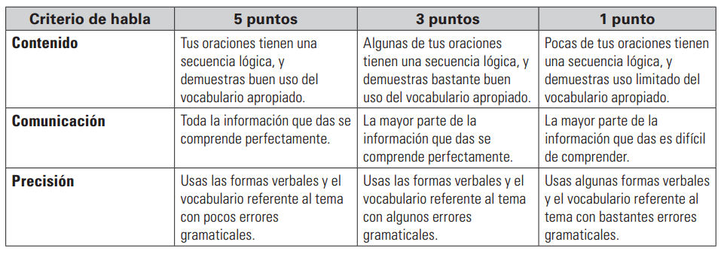

Using online translators is cheating! You may use dictionaries, wordreference.com, and your book.

¿¿¿Preguntas??? Email andy_martin@rockbridge.k12.va.us. I will be checking periodically throughout the summer.

Schedule for First Week of School:
Day 1- Welcome/Intros/Turning in activities from above
Day 2- Review of Activities
Day 3- Test on Lección Preliminar (Grammar/Vocabulary/Reading/Culture/Map of Countries)
Day 4- Start Prezi Presentations
Day 5- Continue Prezi Presentations
Following Week- We will start Unidad 1, Lección 1

Grading Scale for each nine weeks:
Tests 60%
Quizzes 30%
Classwork/ Homework 10%

¡Espero que tengas un verano fantástico!

Cordialmente,
Profe Martin

Nombre:_________________________________ Fecha:_____________________ Clase:_________
Prueba del mapa
Escribe el nombre de la capital y país (in that order) que corresponde con el número.
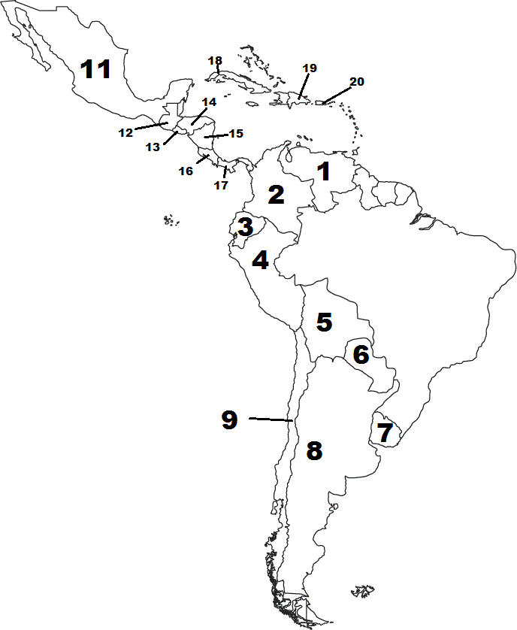
21
10
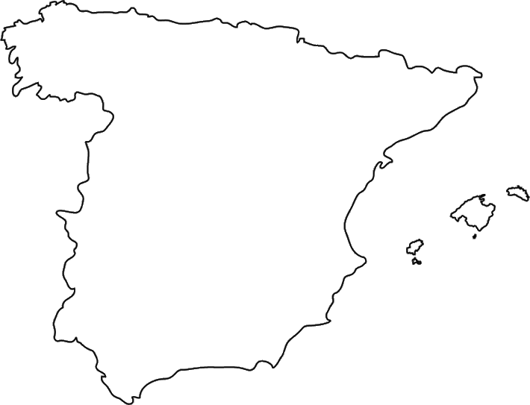

1.
2.
3.
4.
5.
6.
7.
8.
9.
10.
11.
12.
13.
14.
15.
16.
17.
18.
19.
20.
21.

Name | Textbook ID# | Phone # | Email | Initials for receiving assignment

