Answers:
- 4

- $\frac{28-2x}{3x-1}$

  - Y is a function of x
  - Y is a function of x, and x is a function of y
  - Y is a function of x
  - Y is a function of x, and x is a function of y

  - -1
  - -2
  - 1
  - $\frac{6}{x}-\frac{8}{x^{2}}$; Domain $x≠0$

- Graphs
  - x²
  - |x|
  - $\frac{1}{x}$
  - a^{x}
  - $\sqrt{x}$
  - c
  - log_{a}(x)
  - x

  - False. Decreases if x<0
  - True
  - False. Minimum is zero
  - False. It has a horizontal asymptote
  - True
  - True

- Graphs may vary (will cover in class)

  - 15h – 2h²
  - 3 – 4x – 2h

  - c, x, x², x³, |x|, e^{x}, a^{x}
  - x, x³, $\sqrt{x}$, e^{x}, a^{x} (a > 1), $\log_{a}{x}$ (a > 1), $\ln{x,}\frac{1}{x}$
  - None
  - x², |x|
  - x², |x|, $\sqrt{x}$
  - x, x³, $\log_{a}{x},$ $\ln{x}$
  - $\log_{a}{x},$ $\ln{x,}\frac{1}{x}$ , $\frac{1}{x^{2}}$
  - e^{x}, a^{x}, $\frac{1}{x}$ , $\frac{1}{x^{2}}$

  - Domain: $x≠-2$
  - (1.3, 0), (-1.3, 0)
  - (0, -2.5)
  - Vertical: x = -2 Oblique: y = 3x – 6
  - $f\left(x\right)→+∞$
  - $f\left(x\right)→-∞$

- $\left(-∞,1\right]$ or $[1,∞)$

- $-π,-\frac{2π}{3},-\frac{π}{3},0,\frac{π}{3},\frac{2π}{3},π$

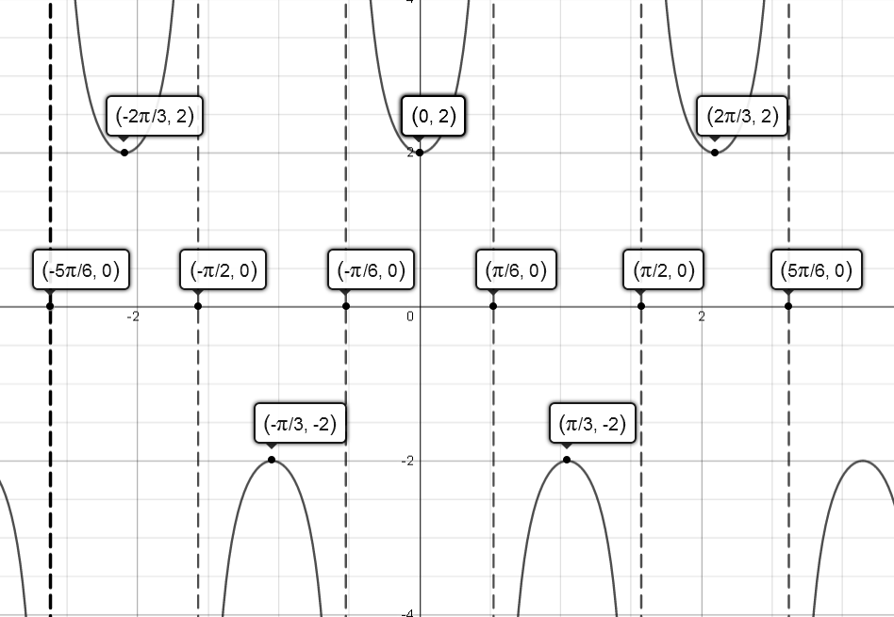
- Phase Shift: $-\frac{π}{6}$

- 108$°$

