Precalculus Honors

Summer Assignment

2016-2017

Why this assignment is useful:

* To help refresh your memory on old math skills you may have forgotten.
* To prepare you for success in the course.
* To help you decide whether this course is best suited for your skill level.

You will receive two grades on this material. One will be a completion grade which will be taken the first day of the school year. The second grade will be a quiz which will be given once we have gone over any areas of concern.

Do not just merely skim over the material. This assignment is a review of mainly algebra and some geometry concepts which will be essential for success in Precalculus.

If you do not have a TI-83 Plus or TI-84 Plus graphing calculator, you need to purchase one over the summer. School calculators are not issued to Precalculus students. Please take this assignment seriously and do not wait until the last minute to begin working the problems. Have a great summer!

*PLEASE NOTE: Although you are allowed to write on this paper, many problems will require additional space. Submitting additional work on notebook paper is highly encouraged.*

Evaluate the expression using the proper order of operations.

1. 

Simplify complex fractions.

1. 

1. For each of the following tables and graphs decide whether y is a function of x and whether x is a function of y?

|  |  |  |  |
| --- | --- | --- | --- |
| x | -4 | 0 | 4 |
| y | 10 | 10 | 10 |

|  |  |  |  |
| --- | --- | --- | --- |
| x | -2 | 0 | 3 |
| y | 6 | 4 | 8 |

1. b.

c. d.

 

1. Given f(x) = 3x – 2x2 and g(x) = , find:
   1. (f + g)(2)
   2. (fg)(2)
   3. ($f o g)(2)$
   4. (*f o g*)(x). Find the domain of *f o g*
2. Match the graph or table with the parent function from the list of functions below :

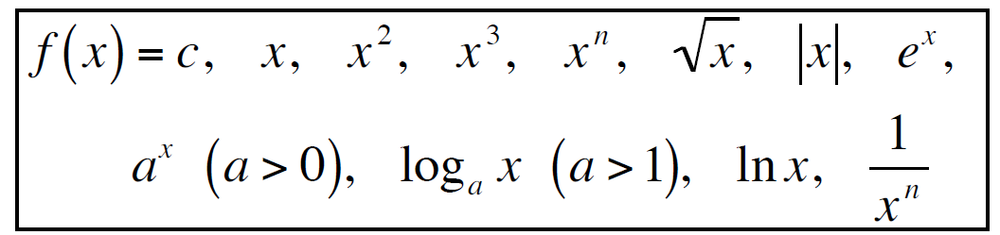

* 1. b.

 

c. d.

 

e. f.

|  |  |  |  |  |
| --- | --- | --- | --- | --- |
| x | 0 | 1 | 4 | 9 |
| y | 0 | 1 | 2 | 3 |

|  |  |  |  |  |
| --- | --- | --- | --- | --- |
| x | -4 | 0 | 4 | 8 |
| y | 5 | 5 | 5 | 5 |

|  |  |  |  |  |
| --- | --- | --- | --- | --- |
| x | -3 | -1 | 1 | 3 |
| y | -30 | -10 | 10 | 30 |

g. h.

|  |  |  |  |  |
| --- | --- | --- | --- | --- |
| x | 0 | 1 | 5 | 25 |
| y | und | 0 | 1 | 2 |

1. Determine if the following statements are true or false. If false, explain why.
2. $f(x)=x^{2}$ increases over its entire domain.
3. $f\left(x\right)=e^{x}$ has no maximum or minimum value.
4. $f\left(x\right)= \sqrt{x}$ has a maximum value of 0.
5. *f(x)* = 10x has a vertical asymptote.
6. $f\left(x\right)=\ln{x}$ has a vertical asymptote.
7. $f\left(x\right)=\frac{1}{x^{2}}$ has both a vertical and horizontal asymptote.
8. Sketch a graph of each of the following functions. Be sure to label intercepts, asymptotes, maximums and minimums and any other important points. Also give the domain and range for each.
   1. y = 2x3 + 11x2 – 12x – 36
9. Given $f\left(x\right)=3x-2x^{2}$, find:
$f\left(-3+h\right)-f(-3)$

$\frac{f\left(x+h\right)-f(x)}{h}$

10. List the functions that have the following properties using the parent functions below:

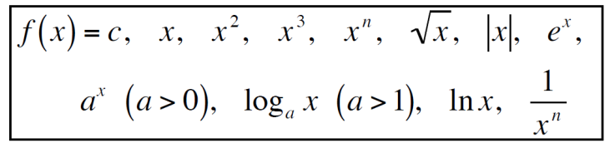

1. Have a domain of $(-∞, ∞)$
2. Are increasing over the entire domain
3. Have a local maximum
4. Have a local minimum
5. Have a range of $[0,∞)$
6. Have a range of $(-∞, ∞)$
7. Have a vertical asymptote
8. Have a horizontal asymptote
9. Graph $f\left(x\right)=\frac{3x^{2}-5}{x+2}$ using your calculator. For a – d, identify the:
10. Domain:
11. Zeros:
12. Y-intercepts:
13. Any asymptotes (vertical, horizontal or oblique):
14. What happens to f(x) as x approaches -2 from the right side of the graph?
15. As $x→-∞$, f(x) $→$

________
16. Give the domain of f(x) = 2x2 – 4x + 5 that will make f -1(x) a function.
17. State all the zeros of f(x) = 4sin(3x + $π$) in the domain - $π ≤x≤ π$.
18. State the asymptotes and phase shift for f(x) = 2csc(3x + $\frac{π}{2}$)in the domain - $π ≤x≤ π$.
19. Convert $\frac{3π}{5}$ to degrees.
20. 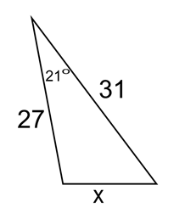Use the laws of sines and cosines to solve this triangle.