English 10 Honors
2017-2018 Summer Assignment

Choose a novel: For your summer assignment, you are expected to do a close reading and complete textual annotations on one of the novels in the following list. While these books are state-approved, students should be advised that these selections are high school novels and may include topics that should be handled with maturity. Parents may choose to preview novels should they so wish.

Furthermore, you are responsible for obtaining a copy of the book. If you cannot acquire a copy, the text can be accessed online (below are some web addresses).

http://www.e4thai.com/e4e/images/pdf/i_know_why_the_caged_bird_sings.pdf
http://www.thehazeleyacademy.com/wp-content/uploads/2014/07/IB-English-The-Kite-Runner-Full-Text.pdf
http://classroom.rfisd.net/users/0192/A%20Separate%20Peace%20by%20John%20Knowles-Full%20Text.pdf

Book Choices:

- I Know Why the Cages Bird Sings by Maya Angelou
- The Kite Runner by Khaled Hosseini
- A Separate Peace by John Knowles

Annotations:

To annotate involves making notes in/on a text as you read so that it shows your critical thinking and analysis of the text. Think of annotation as writing notes that provide active interaction with a text while making your thinking obvious to an outside observer.

Your annotations should focus on the following:
1. Exploration of culture: the shared set of arts, ideas, skills, institutions, customs, attitude, values, and achievements that characterize a group of people, and that are passed on or taught to succeeding generations.
2. Tracking and identifying: Symbols, Imagery, Figurative Language/Rhetorical Strategies, Tone, and Theme
Your assignment:

Please LEGIBLY annotate the text in the margins, on sticky notes, or by way of a double-entry journal. Please note that annotating includes both marking literary elements and noting what you feel the text might be revealing about culture. Please write in the margins of the text if you own your own copy or use sticky notes/double-entry journal if you are borrowing the text. Read the provided scoring rubric carefully.

(over)

Three Levels of Annotation
Your annotations should attend to all three levels of questioning the text:
Level 1 | Level 2 | Level 3
Literal– found directly in the text | Interpretative/Analytical– found by making inferences | Universal/Thematic– found outside of the text
Questions/notes that check for understanding | Questions/notes about the author’s choices | Questions/notes about how the text relates to the world outside the text, including how it relates to my life and what I know.

You can choose to annotate the text for this assignment in three different ways:
1) Mark the Text OR | 2) Use Post-It Notes OR | 3) Create a Double Entry Journal
Please obtain the text and annotate in the margins. Your teacher will collect the text and assess your annotations using the rubric.  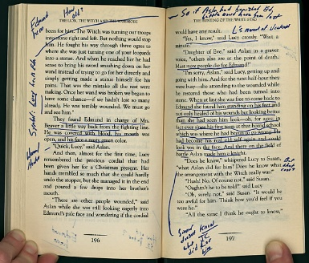 | Annotate the text on post-it notes and place them in the book. Your teacher will collect the book and post-it notes to assess your annotations using the rubric  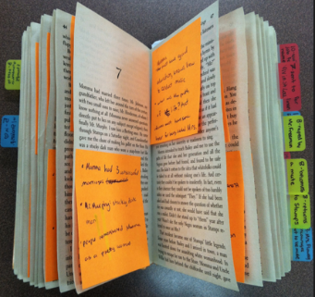 | If you would like to interact with the text using a double entry journal, please create a journal using the example below. In the first column provide the text to which you are responding, and in the second column give your thoughts  Text and Page Number Connections and Insights  “You were the river current carrying the roaring notes” (16). The speaker uses a metaphor to compare her mother to the current in a fast-flowing river that seems to be carrying a song. The song might represent…

If you have any questions, you may contact me at sarah_leadbetter@rcs.rang.k12.va.us; however, please be advised that I check my school email just a few times over the summer, so the sooner you send an email, the better.
On the first day of the 2017-2018 school year, you should be prepared for a formal assessment on your novel choice.

