Summer Assignment Problem Set

1.66 Suppose you try to define your own temperature scale using the freezing point (-11.5◦C) and boiling point
(197.6◦C) of ethylene glycol. If you set the freezing point as 0◦G and the boiling point as 100◦G, what is
the freezing point of water on this new scale?

1.67 The liquid substances mercury (density = 13.5 g/mL) water (1.00g/mL), and cyclohexane (0.778g/mL) do
not form a solution when mixed, but separate in distinct layers. Sketch how the liquids would position
themselves in a test tube.

1.72 Automobile batteries contain sulfuric acid, which is commonly referred to as “battery acid.” Calculate
the number of grams of sulfuric acid in 0.500 L of battery acid if the solution has a density of 1.28 g/mL
and is 38.1% sulfuric acid by mass.

1.75 A package of aluminum foil contains 50 ft² of foil, which weighs approximately 8.0 oz. Aluminum has a
density of 2.70 g/cm³. What is the approximate thickness of the foil in millimeters?

2.87 Identify the element represented by each of the following symbols and give the number of protons and
74
33
127
53
neutrons in each a) X b) X

2.90 The element lead (Pb) consists of four naturally occurring isotopes with atomic mass 203.97302,
205.97444, 206.97587, and 207.97663 amu. The relative abundances of these four isotopes are 1.4, 24.1,
22.1, and 52.4%, respectively. From these data, calculate the atomic weight of lead.

2.98 Name each of the following oxides. Assuming that the compounds are ionic, what charge is associated
with the metallic element in each case? a. NiO b. MnO₂ c. Cr₂O₃ d. MoO₃

2.102 Give the chemical names of each of the following familiar compounds: a. NaCl (table salt)
b. NaHCO₃ (baking soda) c. NaOCl (in many bleaches) d. NaOH (caustic soda)
e. (NH₄)₂CO₃ (smelling salts) f. CaSO₄ (plaster of Paris)

2.104 Many ions and compounds have very similar names, and there is great potential for confusing them.
Write the correct chemical formulas to distinguish between
a. calcium sulfide and calcium hydrogen sulfide b. hydrobromic acid and bromic acid
c. aluminum nitride and aluminum nitrite d. iron(II) oxide and iron(III) oxide
e. ammonia and ammonium ion f. potassium sulfite and potassium bisulfite
g. mercurous chloride and mercuric chloride h. chloric acid and perchloric acid.

2.105 The compound cyclohexane is an alkane in which six carbon atoms form a ring. The partial structural
formula of the compound is as follows:
a. Complete the structural formula for cyclohexane.
b. Is the molecular formula for cyclohexane the same as
that for n-hexane, in which the carbon atoms are in a
straight line? If possible, comment on the source of
any differences.

3.82 The effectiveness of nitrogen fertilizers depends on both their ability to deliver nitrogen to plants and the
amount of nitrogen they can deliver. Four common nitrogen-containing fertilizers are ammonia,
ammonium nitrate, ammonium sulfate, and urea [(NH₃)₂CO]. Rank these fertilizers in terms of the mass
percentage nitrogen they contain.

3.87 The koala dines exclusively on eucalyptus leaves. Its digestive system detoxifies the eucalyptus oil, a
poison to other animals. The chief constituent in eucalyptus oil is a substance called eucalyptol, which
contains 77.87% C, 11.76% H, and the remainder O. a. What is the empirical formula for this substance?

3.99 When a mixture of 10.0 g of acetylene (C₂H₂) and 10.0 g of oxygen (O₂) is ignited, the resultant
combustion reaction produces CO₂ and H₂O. a. Write the balanced chemical equation for this reaction.
b. Which is the limiting reactant? c. How many grams of C₂H₂ are present after the reaction is
complete?

4.92 The reaction between Cd(NO₃)₂ and Na₂S produces a precipitate. What is the identity of the precipitate?
What ions remain in solution? Write the net ionic equation for the reaction.

5.98 A coffee-cup calorimeter contains 150.0 g of water at 25.1◦C. A 121.0-g block of copper metal is heated
to 100.4◦C by putting it in a beaker of boiling water. The specific heat of Cu(s) is 0.385 J/g-K. The Cu is
added to the calorimeter, and after a time the contents of the cup reach a constant temperature of 30.1◦C.
a. Determine the amount of heat, in J, lost by the copper block.

6.15 a. What is the frequency of radiation that has a wavelength of 10 μm, about the size of a bacterium?
b. What is the wavelength of radiation that has a frequency of 5.50x10¹⁴ s⁻¹? c. Would the radiations in
part “a” or part “b” of this problem be visible to the human eye?
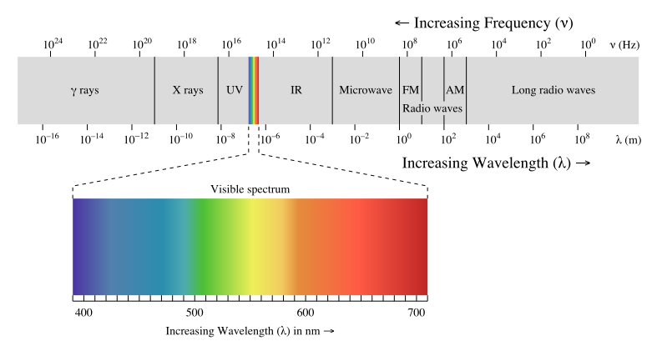

6.73 What is wrong with the following electron configurations for atoms in their ground states? a. 1s²2s²3s¹
b. [Ne]2s²2p³ c. [Ne]3s²3d⁵

7.45 Based on their positions in the periodic table, predict which atom of the following pairs will have the
larger first ionization energy: a. Cl, Ar b. Be, Ca c. K, Co d. S, Ge e. Sn, Te

7.48 Write the electron configurations for the following ions, and determine which have noble-gas
configurations: a. Cr³⁺ b. N³⁻

8.88 Calculate the formal charge on the indicated atom in each of the following molecules or ions: a. the
central oxygen atom in O₃

9.79 From their Lewis structures, determine the number of σ and π bonds in each of the following molecules
or ions: b. thiocyanate ion, NCS⁻ c. formaldehyde, H₂CO

10.91 A gas bubble with a volume of 1.0 mm³ originates at the bottom of a lake where the pressure is 3.0 atm.
Calculate its volume when the bubble reaches the surface of the lake where the pressure is 695 torr,
assuming that the temperature doesn’t change.

10.93 To minimize the rate of evaporation of the tungsten filament, 1.4x10⁻⁵ mol of argon is placed in a 600-cm³
lightbulb. What is the pressure of argon in the lightbulb at 23◦C?

11.56 The normal melting and boiling points of O₂ are -218◦C and -183◦C respectively. Its triple point is at
-219◦C and 1.14 torr, and its critical point is at -119◦C and 49.8 atm. a. Sketch the phase diagram for O₂,
showing the four points given and indicating the area in which each phase is stable.

13.24 Referring to the following diagram,
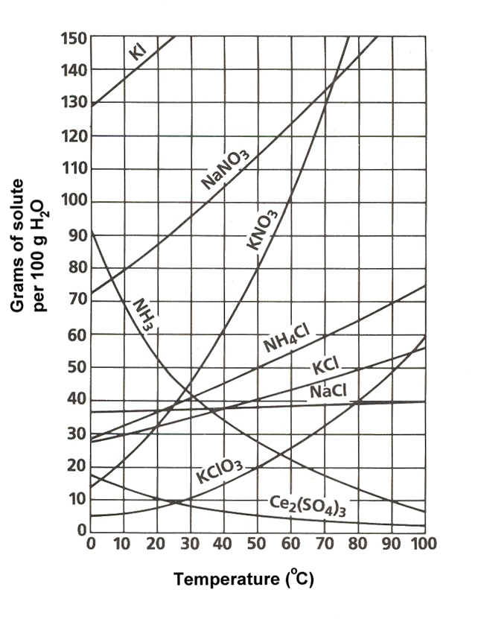
determine the mass of each of the
following salts required to form a
saturated solution in 250 g of water
at 30◦C: a. KClO₃

13.89 Fish need at least 4 ppm dissolved O₂ for survival. A. What is this concentration in mol/L?

13.69 Using data from the following table, calculate the freezing and boiling points of each of the following
solutions: a. 0.22 m glycerol (C₃H₈O₃) in ethanol.

14.7 The following diagram shows the reaction profile of a reaction. Label the components indicated by the
boxes.
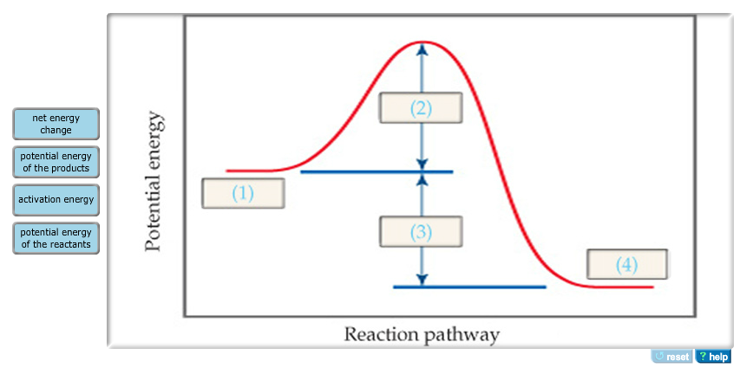
15.14 Write the expressions for K_{eq} for the following reactions. In each case indicate whether the reaction is
homogeneous or heterogeneous. a. 2O₃(g) ⇆ 3O₂(g) b. Ti(s) + 2Cl₂(g) ⇆ TiCl₄(l)

16.39 Complete the following table by calculating the missing entries and indicating whether the solution is
acidic or basic.
[H⁺] | [OH⁻] | pH | pOH | acidic or basic
7.5x10⁻³ M

17.6 Match the following descriptions of titration curves with the diagrams:
a. strong acid added to strong base c. strong based added to strong acid
b. strong based added to weak acid d. strong base added to polyprotic acid

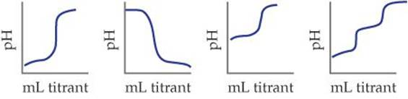
(i) (ii) (iii) (iv)

